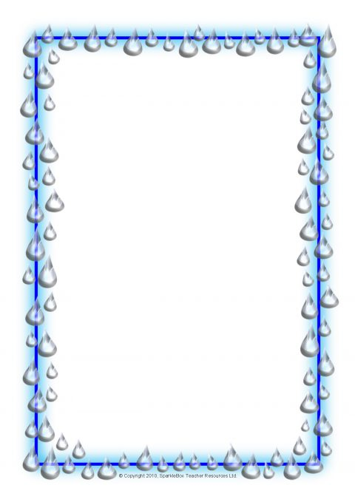
Whaea Rachael helped me get in the pool. I swum with a noodle. On Tuesday, we did Ring-a-Rosie. It was so exciting and we put our head under the water. On Wednesday, I went to the Aquatic Centre and I had lots of fun! I had to kick my legs. On Thursday, I held a flutter board with straight arms. I had to kick my legs. On Friday, we were holding the board. Swimming this week was fun.
By Kylah

This morning we went to the Aquatic Centre. In my group, we learnt to kick out of the wall and we swum to the swimming teacher. It was cool when we kicked off the wall. BAM! I loved it because we got small flutter boards. It was cool, hundred times cool!
On Tuesday, my group did rocket arms and we swam to the teacher. We stood in a line to swim. We had to sit on the wall, before we had our turn, patiently. My friends were in my group, Jayden, Lavinia, Herewini and Krimson. It was kind of difficult for us!
On Thursday, my group did rocket arms. I thought it was difficult for us.
On Friday, swimming was too fun! We had a swimming race. Lavinia beat me and we played ‘Simon says’ in the pool.
Swimming this week was choice!
By Meekah

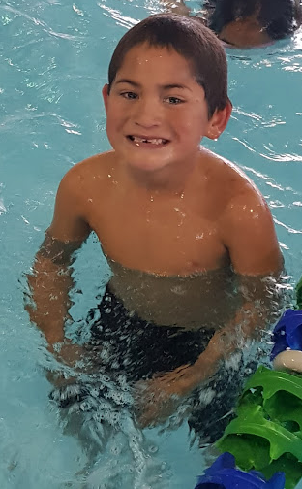
Today I did rocket arms in the pool. It was easy.
Today I had to turn from my puku to my back. It was easy.
Today I had to put my eyes under the water.
Today I played ‘Simon says’ in the pool.
By Lennox

I was swimming and it was fun. I went on a bus. The swimming pool was warm.
On Tuesday, I was floating on my back and it was fun! It was easy.
On Wednesday, I went to the Aquatic Centre and I had to blow bubbles. It was fun.
On Thursday, I was kicking my legs and it was hard.
On Friday, I had to float on my back and I had to turn on my stomach but it was hard.
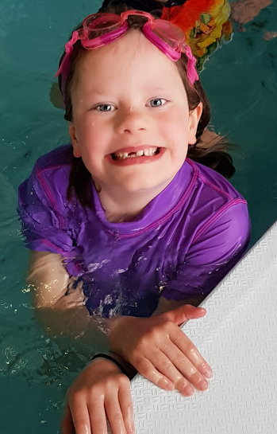
Swimming this week was challenging.
By Chelsea

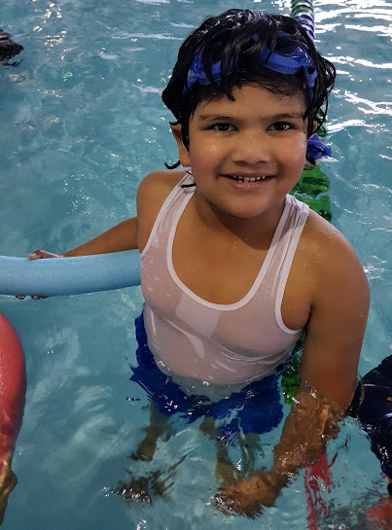
In the pool, the swimming is easy-peasy. It’s fun and I had a good time. It’s great. The teacher said to get a noodle. I swum with the noodle.
On Thursday, I went to the swimming pool again! Today I learnt how to hold the flutter board and go down in the water.
The Aquatic Centre is awesome! We made a train. We had to hold our partners shoulders. We even had to push our legs! It’s a little bit tricky. The Aquatic Centre is brilliant!
By Zayed

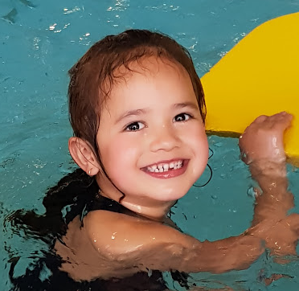
This morning we went to the Aquatic Centre to learn how to swim. We had to swim with a flutter board. After that we came back to school in a bus. When we got back from swimming we wrote about swimming at the Aquatic Centre. It was exciting and it was fun.
On Tuesday, we went to the Aquatic Centre again. On the way to the Aquatic Centre I felt shy and excited. My mum came to watch me swim. My group had to kick our legs and put our chin on our chest and swim under water. It was really, really tricky.
On Wednesday, we went to the Aquatic Centre. When my group was learning how to swim my Aunty brought me some goggles. After that I was swimming with my brand-new goggles. At the end of swimming at the Aquatic Centre I went back to school.
On Thursday, we went back to the Aquatic Centre. My group had to sit on the wall and kick our legs and keep them straight. Then we got changed and then went back to school.
On Friday, we back to the Aquatic Centre, the last day of school. My group had to swim on our puku and then turn around onto our backs.
Swimming the week was AMAZING!
By Mia-Marie

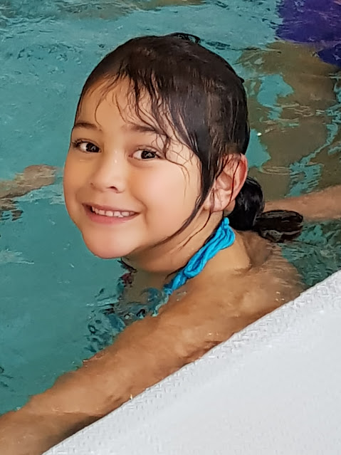
This morning I went swimming. We went to the Aquatic Centre. We had to float on our back. It was fun floating on our back.
On Tuesday, I went swimming. Our teachers’ names were Wonder Woman and Maui. I floated on my back. I felt amazing and excited. When I floated on my back, I felt like a butterfly and I felt like was sinking. It was a bit scary when I felt like that.
Wednesday’s swimming, I went in the deep pool. Wonder Woman taught us some swimming lessons. She’s amazing. She taught us to float on my back and turn around and float on our tummy. It was really challenging.
On Thursday morning, we all got ready. We got to go on the bus. I had to kick my legs. We had to kick slow. It was fun!
Swimming was amazing on Friday in the deep pool with Wonder Woman. Swimming this week was exciting. I had to kick my feet in the water. It was challenging. After that we had a challenge about blowing bubbles the longest.
By Taeao

Today we went to the Aquatic Centre. I had a noodle to swim with. I felt good! It made me happy.
On Tuesday, Room 7 went to the Aquatic Centre, again! We did Ring-a-Rosie. It made me happy! Also. we did floating too. It was exciting and it also made me excited. It made me like going swimming.
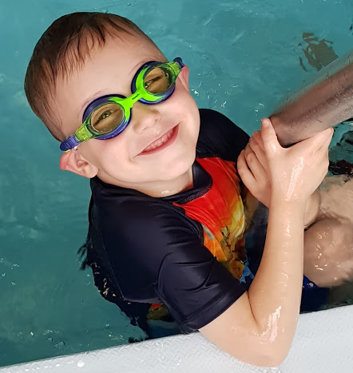
On Wednesday, we did swimming, again! I did not get to paddle. I got to float. Well, I was so happy! I got to do Ring-a-Rosie at the end of the day at swimming. I was super HAPPY!
Tomorrow, we went back to swimming! Again, I got to do floating on my back and my tummy too. Then I did not get to do Ring-a-Rosie at the end of the day. The swimming was fun.
I LOVED going to swimming. I was excited at swimming! I floated good. I was like a fish. I got a little bit of water in my eyes. It was challenging. It was easy. We went to swimming again! It was Friday.
By Travis
Today I went to the Aquatic Centre. It was fun when we dived in the water.
On Tuesday, I did rocket arms at the Aquatic Centre. It was fun. It was easy.
On Wednesday, we went to the Aquatic Centre. We did rocket arms and it was hard.
On Thursday, we did rocket arms again. In the pool, I did rocket arms in the water.
On Friday, swimming was hard. We did rocket arms again. Swimming this week was choice.
By Krimson

I had so much fun! We did some floating on our backs and we had so much fun and I liked it.
On Tuesday, I did swimming and it was exciting. I liked it. We did floating on our backs. It was hard.
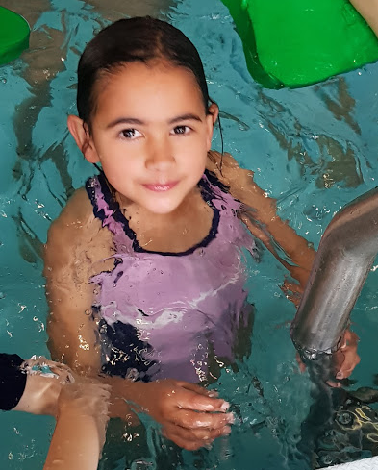
On Wednesday, I went to the Aquatic Centre. I did floating on my stomach. It was hard for me and it was fun.
On Thursday morning, I did swimming. It was exciting. I used rocket arms and I dived in the water. I put my chin on my chest.
Swimming this week was awesome.
By Indera-Lee

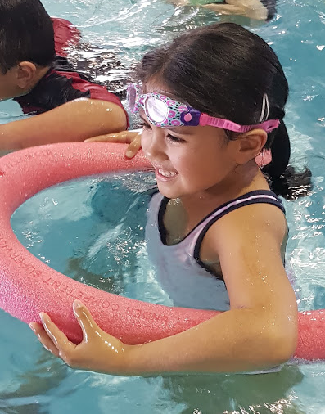
I blew bubbles in the pool with Stevie. It was fun.
In the pool, I played water fountain.
I put my eyes under the water. I felt good.
I held a flutter board in the pool.
Swimming this week was fun!
By Deon
We went to the Aquatic Centre to swim. It was fun.
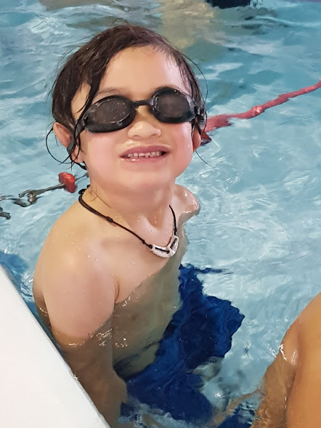
Today I did Rocket arms in the pool. It was fun.
Today we went to the Aquatic Centre. I turned around in the water.
Today at swimming I kicked my legs.
I was at swimming.
By Herewini

This morning we went to the swimming pools. It was fun swimming at the pools.
On Tuesday, I went swimming. It was fun swimming in the pool. It was fun in the pools.
We went swimming in the water. We had to lie on our backs, then we had to lay on our tummies.
Wednesday’s swimming was fun. I had to put our hair in the pool water.
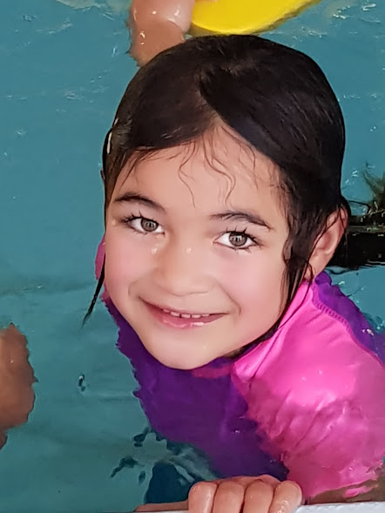
On Thursday, I had to lay on my back again. The pool is fun.
On Friday at the Aquatic Centre, we had to kick our legs. It was tricky. This week was brilliant. It was exciting. It was challenging.
By Mahinarangi

When we were at the swimming pool, I was excited!
Today I used a flutter board to kick my legs.
I went under the water. It was hard.
When we went to the pool, I jumped in the pool.
I went swimming.
By Kiana

I was blowing bubbles in the pool. It was exciting.
On Tuesday, we played Ring-a-Rosie and it was fun playing and we played a cool game in the pool. It was exciting.
On Wednesday, I was floating on my back and then we had to do rocket arms and it was easy.
On Thursday, I was holding the flutter board and it was easy for me and we had to kick our legs.
Swimming was exciting.
By Azalea
I did rocket arms in the pool.

Swimming was amazing.

By Shannon.
